ASSIGNMENT NO-1

**NAME –** Shubham Vijay Borage

**Class -** MCA

**Roll No. -**

**Q.** Write a java program to find factorial of a number using recursion.

**INPUT**:

package assignment41;

import java.util.Scanner;

public class factorial1

{

public static int fact(int num)

{

if(num==0)

{

return 1;

}

else

{

return num\**fact*(num-1);

}

}

public static void main(String[] args)

{

Scanner in = new Scanner(System.*in*);

System.*out*.println("Enter a number");

int num = in.nextInt();

System.*out*.println("Factorial of a number is:"+*fact*(num));

in.close();

}

}

**OUTPUT:**

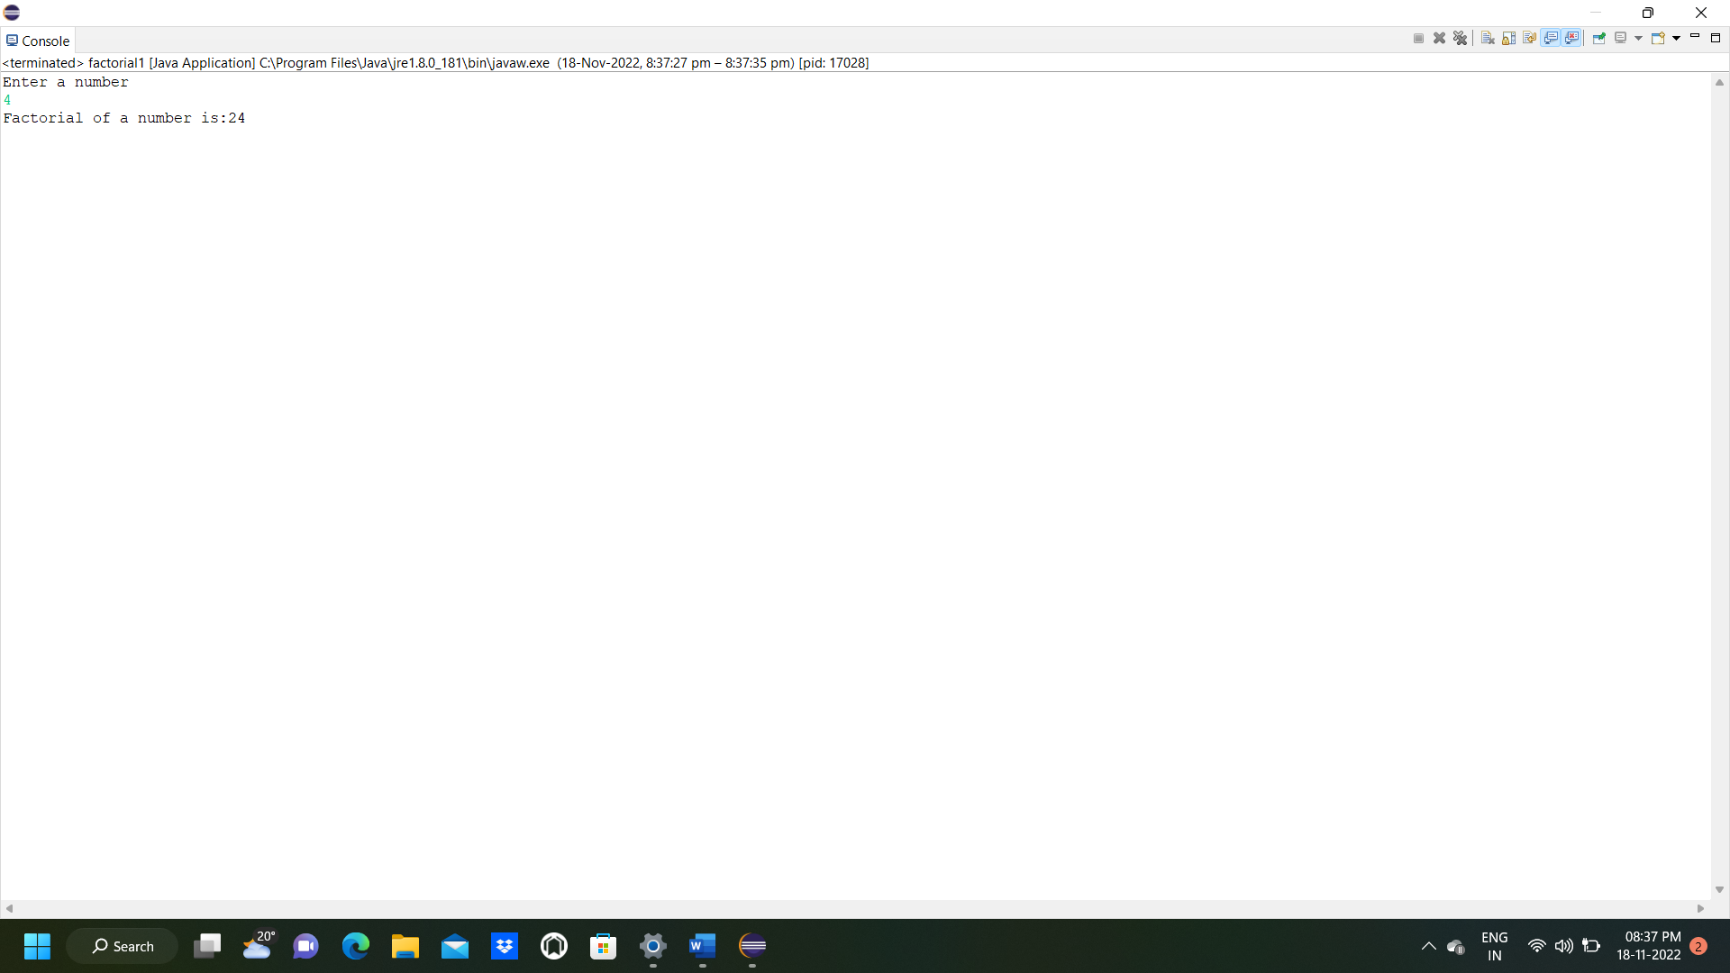

ASSIGNMENT NO 2

**NAME -** Shubham Vijay Borage

**Class -** MCA

**Roll No. -**

**Q**. Write a java program to find largest and smallest number of array.

**INPUT**:

package assignment41;

import java.util.Scanner;

public class findlargestsmallest {

static

*totalNumber*;

static int *num*[];

static int largest(int arr[]) {

int largestNum=*num*[0];

for(int i=0;i<arr.length;i++) {

if(*num*[i]>largestNum) {

largestNum=*num*[i];

}

}

return largestNum;

}

static int smallest(int arr[]) {

int smallestNum=*num*[0];

for(int i=0;i<arr.length;i++) {

if(*num*[i]<smallestNum) {

smallestNum=*num*[i];

}

}

return smallestNum;

}

public static void main(String[] args) {

try (Scanner input = new Scanner(System.*in*)) {

System.*out*.println("How many number you want to enter?:");

*totalNumber*=input.nextInt();

*num*=new int[*totalNumber*];

System.*out*.println("Enter values:");

for(int i=0;i<*totalNumber*;i++) {

*num*[i]=input.nextInt();

}

}

System.*out*.println("largest number: "+*largest*(*num*));

System.*out*.println("smallest number: "+*smallest*(*num*));

}

}

}

**OUTPUT:**

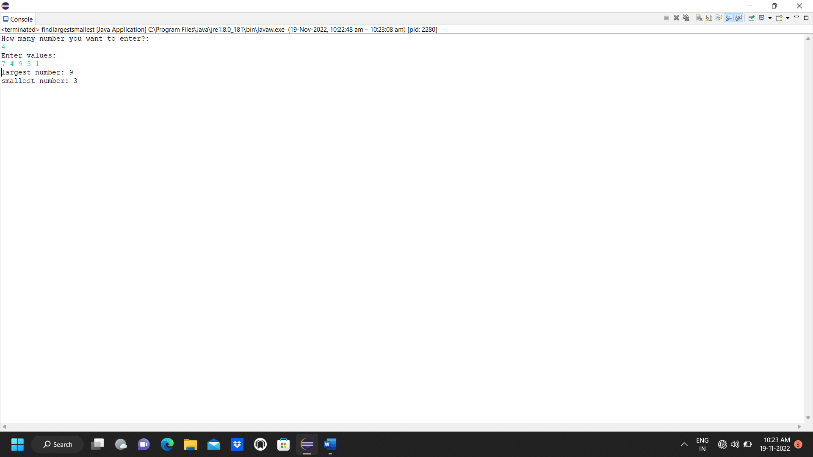

ASSIGNMENT NO 3

**NAME -** Shubham Vijay Borage

**Class -** MCA

**Roll No. -**

**Q.** Write a java program to reverse the string

**INPUT:**

package assignment41;

import java.util.Scanner;

public class reversestring {

public static void main(String args[])

{

String original, reverse ="";

Scanner in = new Scanner(System.*in*);

System.*out*.println("Enter a string to reverse");

original = in.nextLine();

int length = original.length();

for(int i=length-1; i>=0; i--)

reverse = reverse + original.charAt(i);

System.*out*.println("Reverse of string:"+ reverse);

in.close();

}

}

**OUTPUT:**

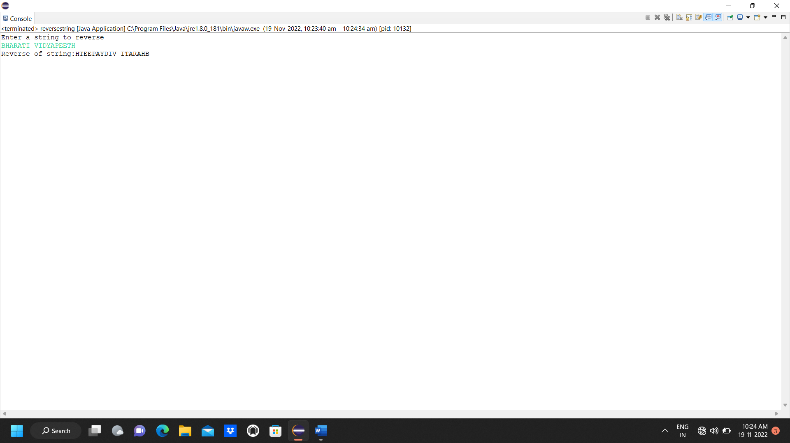

ASSIGNMENT NO 4

**NAME -** Shubham Vijay Borage

**Class -** MCA

**Roll No. –**

**Q.** Write a java program to sort the array elements

**INPUT:**

package assignment41;

import java.util.Scanner;

public class sortascending {

public static void main(String[] args) {

// TODO Auto-generated method stub

int n, temp;

try (Scanner s = new Scanner(System.*in*)) {

System.*out*.print("Enter no. of elements you want in array:");

n = s.nextInt();

int a[] = new int[n];

System.*out*.println("Enter all the elements:");

for (int i = 0; i < n; i++)

{

a[i] = s.nextInt();

}

for (int i = 0; i < n; i++)

{

for (int j = i + 1; j < n; j++)

{

if (a[i] > a[j])

{

temp = a[i];

a[i] = a[j];

a[j] = temp;

}

}

}

System.*out*.print("Ascending Order:");

for (int i = 0; i < n - 1; i++)

{

System.*out*.print(a[i] + ",");

}

System.*out*.print(a[n - 1]);

}

}

}

**OUTPUT:**

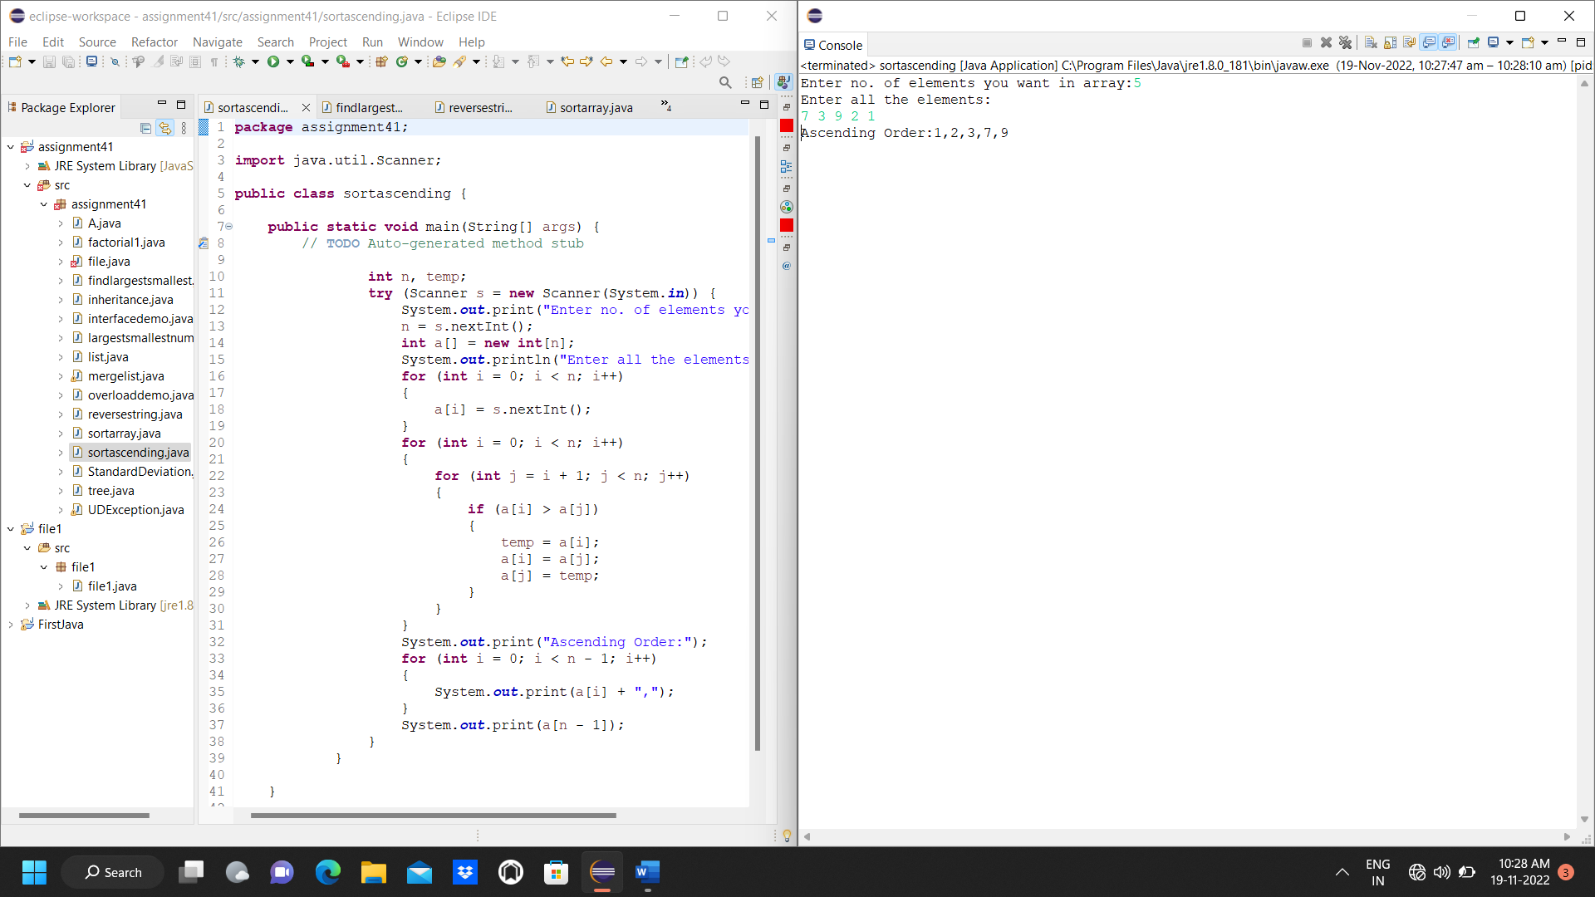

ASSIGNMENT NO 5

**NAME -** Shubham Vijay Borage

**Class -** MCA

**Roll No. –**

**Q**. Write a java program to demonstrate concept of inheritance.

**INPUT:**

package assignment41;

class doctor{

float salary=50000;

}

class surgeon extends doctor{

float bonus=20000;

}

public class inheritance {

public static void main(String[] args) {

// TODO Auto-generated method stub

surgeon s=new surgeon();

System.*out*.println("salary of sergeon"+s.salary);

System.*out*.println("bonus of sergeon"+s.bonus);

}

}

**OUTPUT:**

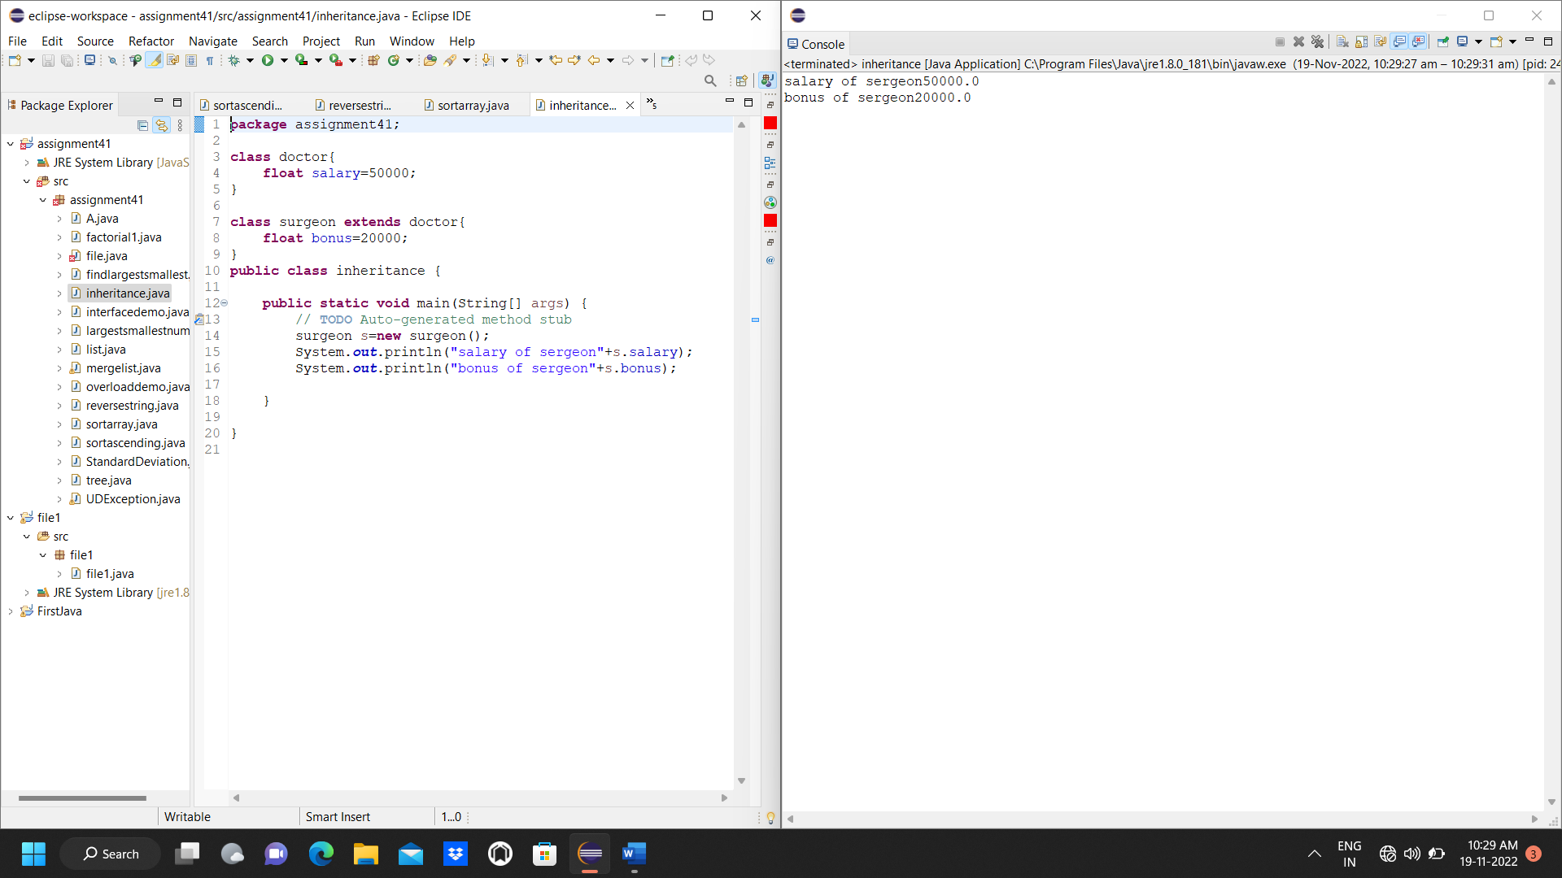

ASSIGNMENT NO 6

**NAME -** Shubham Vijay Borage

**Class -** MCA

**Roll No. –**

**Q.** Write a java program to demonstrate concept of interface.

**INPUT:**

package assignment41;

interface printable

{

void print();

}

class A6 implements printable

{

public void print()

{

System.*out*.println("Hello");

}

}

public class interfacedemo

{

public static void main(String[] args)

{

// TODO Auto-generated method stub

A6 obj=new A6();

obj.print();

}

}

**OUTPUT:**

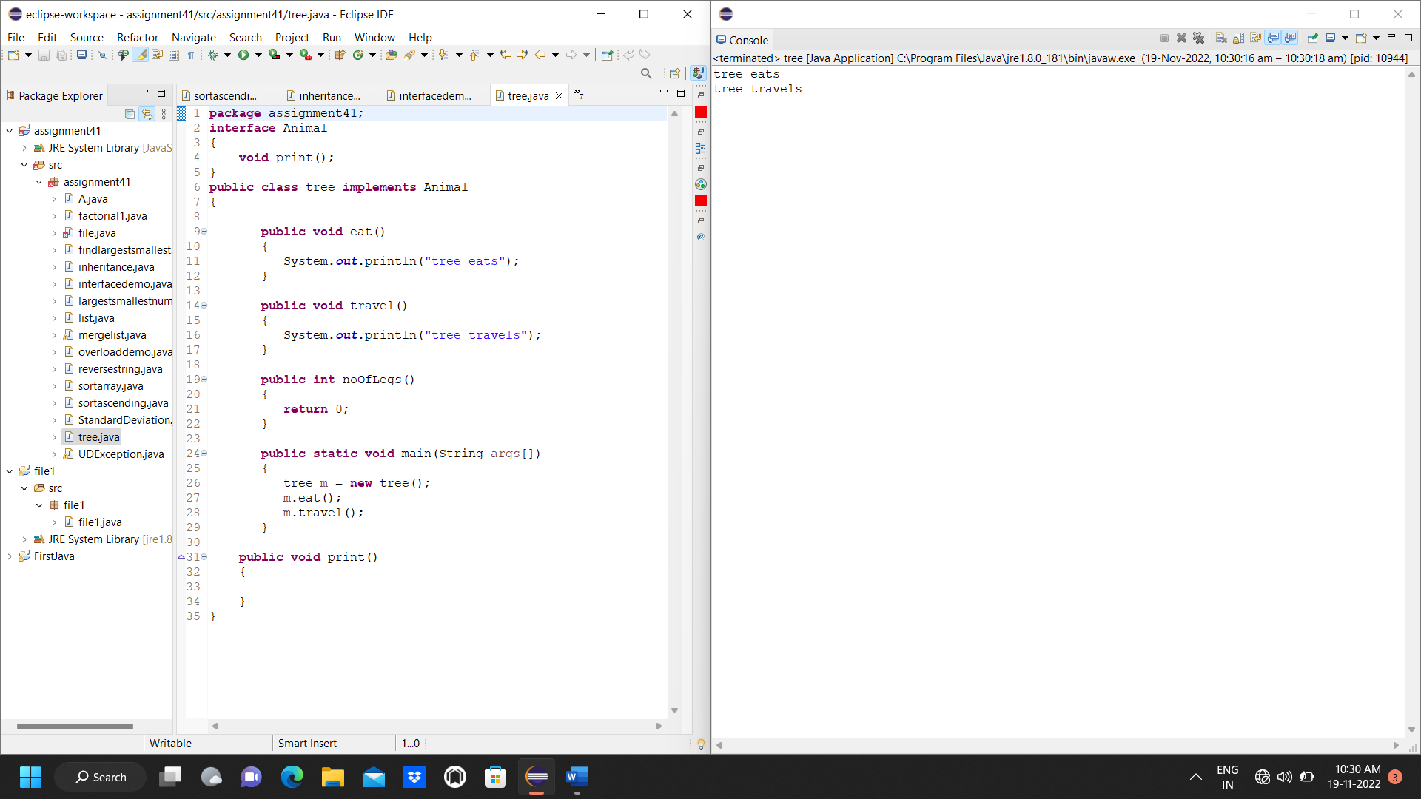

ASSIGNMENT NO 7

**NAME -** Shubham Vijay Borage

**Class -** MCA

**Roll No. –**

**Q.** Write a java program to demonstrate concept of overloading and constructor overloading.

**INPUT:**

package assignment41;

class Box{

double width, height, depth;

Box(double x){

width = height = depth = x;

}

Box(double w, double h,double x){

width = w;

height = h;

depth = x;

}

public void volume() {

double vol;

vol=width*depth*height;

System.*out*.println("Volume of the box is:"+vol);

}

}

public class overloaddemo {

public static void main(String[] args) {

Box b1 = new Box(5,6, 3);

Box b2 = new Box(8,5,4);

b1.volume();

b2.volume();

}

}

**OUTPUT:**

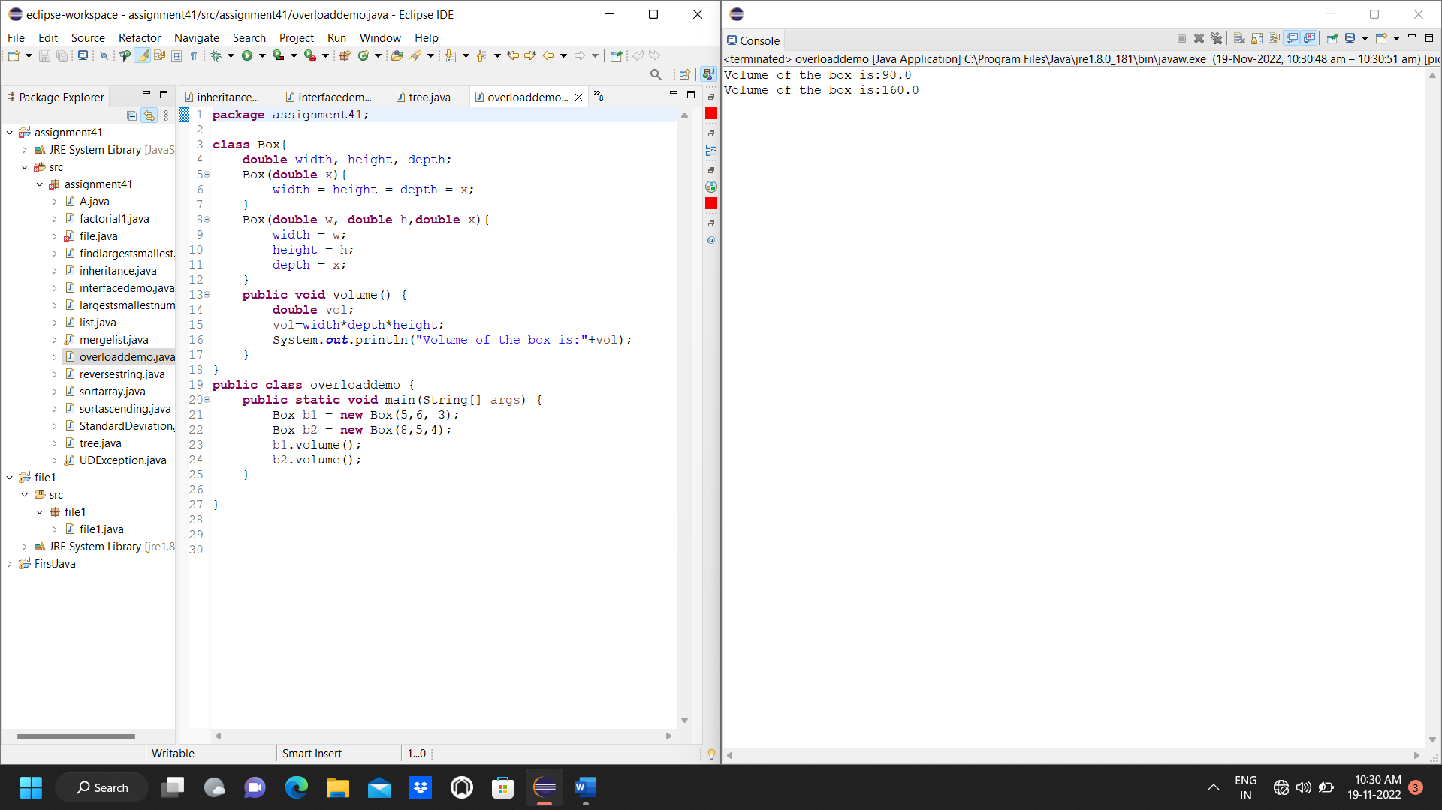

ASSIGNMENT NO 8

**NAME -** Shubham Vijay Borage

**Class -** MCA

**Roll No. -**

**Q.** Write a java program to create an implement a package in java.

**INPUT:**

package pack;

public class A

{

public void msg()

{

System.*out*.println("Hello");

}

}

package mypack;

import pack.A;

public class B

{

public static void main(String[] args)

{

A obj=new A();

obj.msg();

}

}

**OUTPUT:**

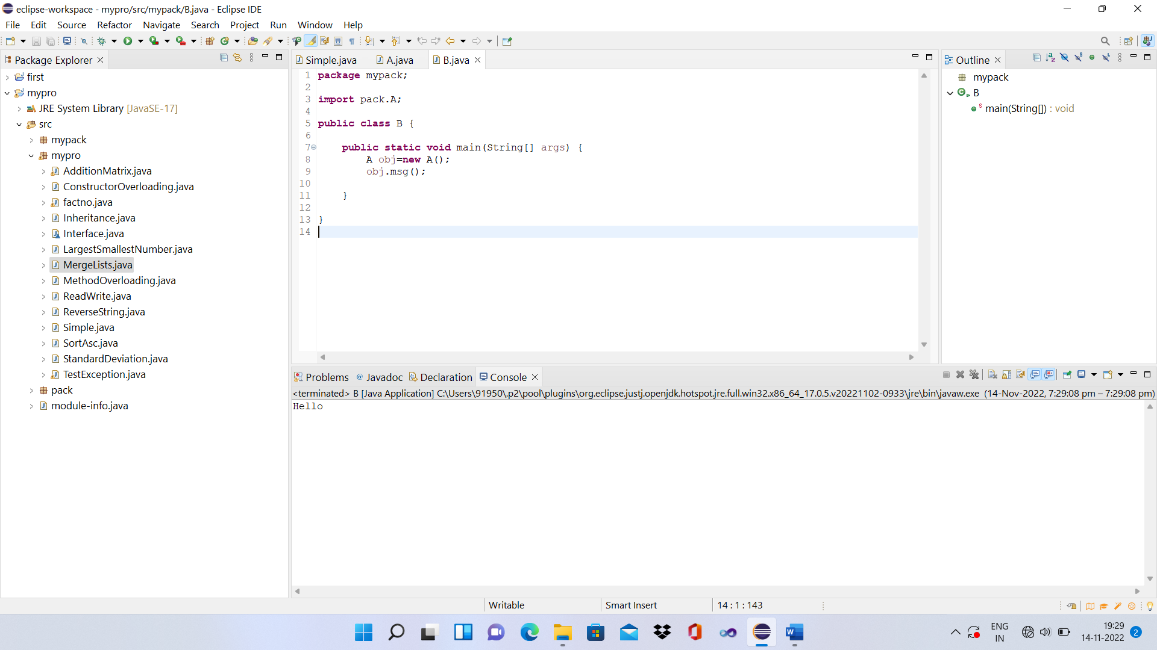

ASSIGNMENT NO 9

**NAME -** Shubham Vijay Borage

**Class -** MCA

**Roll No. –**

**Q**. Write a java program to demonstrate user define exception.

**INPUT:**

package assignment41;

class InvalidAgeException extends Exception

{

public InvalidAgeException (String str)

{

super(str);

}

}

public class UDException

{

static void validate (int age) throws InvalidAgeException

{

if(age<18)

{

throw new InvalidAgeException("Age is not valid to vote..");

}

else

{

System.*out*.println("Welcome to Vote..");

}

}

public static void main(String[] args)

{

try

{

*validate*(13);

}

catch (InvalidAgeException ex)

{

System.*out*.println("Caught the Exception..");

System.*out*.println("Exception Occured : "+ex);

}

System.*out*.println("Rest of the Code..");

}

}

**OUTPUT:**

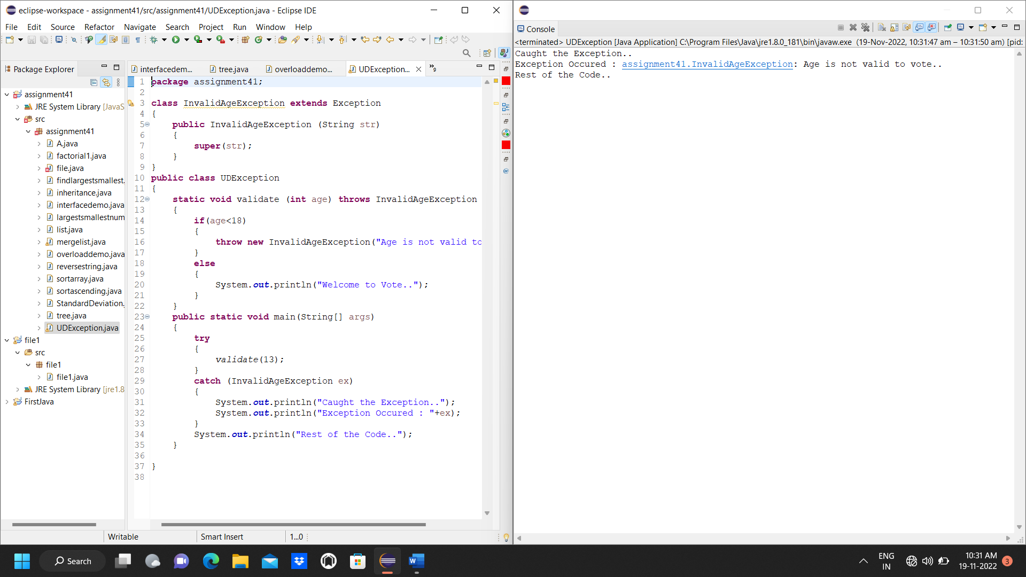

ASSIGNMENT NO 10

**NAME -** Shubham Vijay Borage

**Class -** MCA

**Roll No. -**

**Q.** Write a java program to add two matrix using multidimensional array.

**INPUT:**

package assignment41;

import java.util.*;

public class A {

public static void main(String[] args) {

// TODO Auto-generated method stub

int row,col,i,j;

Scanner in = new Scanner(System.*in*);

System.*out*.println("Enter the number of rows");

row =in.nextInt();

System.*out*.println("Enter the number of columns");

col =in.nextInt();

int mat1[][]=new int[row][col];

int mat2[][]=new int[row][col];

int res[][]=new int[row][col];

System.*out*.println("Enter the element of matrix1");

for(i=0; i<row; i++)

{

for(j=0; j<col; j++)

mat1[i][j] =in.nextInt();

System.*out*.println();

}

System.*out*.println("Enter the element of matrix2");

for(i=0; i<row; i++)

{

for(j=0; j<col; j++)

mat2[i][j] =in.nextInt();

System.*out*.println();

}

for(i=0; i<row; i++)

for(j=0; j<col; j++)

res[i][j] = mat1[i][j] + mat2[i][j];

System.*out*.println("Sum of matrices:-");

for(i=0;i<row;i++)

{

for(j=0;j<col;j++)

System.*out*.print(res[i][j]+"\t");

}

}

}

**OUTPUT:**

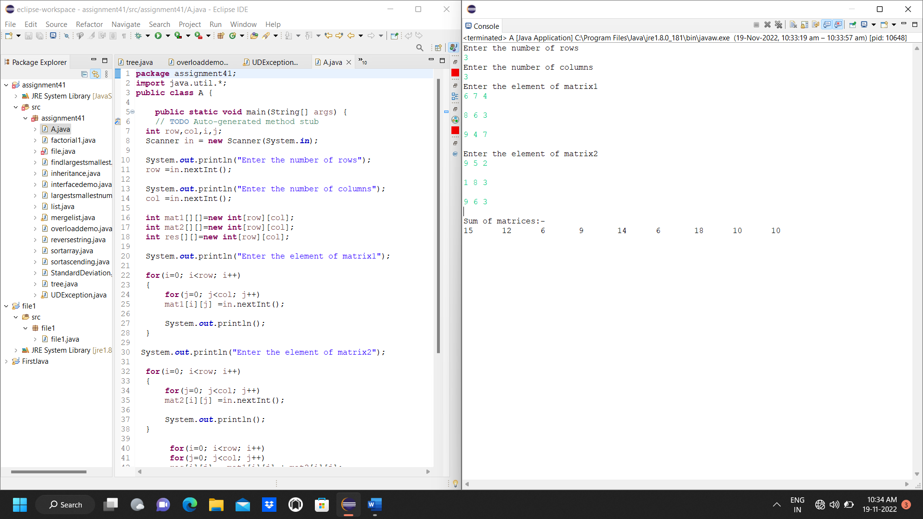

ASSIGNMENT NO 11

**NAME -** Shubham Vijay Borage

**Class -** MCA

**Roll No. -**

**Q.** Write a java program to read the content from one file and write to another file.

**INPUT:**

package file1;

import java.io.*;

public class file1

{

public static void main(String[] args)

{

File inf = new File("in.txt");

File outf = new File("out.txt");

FileReader ins = null;

FileWriter outs = null;

try

{

ins = new FileReader(inf);

outs = new FileWriter(outf);

while ((ins.read()) != -1)

{

System.*out*.println();

}

System.*out*.println("File Copied");

}

catch (IOException e)

{

System.*out*.println(e);

System.*exit*(-1);

}

finally

{

try

{

ins.close();

outs.close();

}

catch (IOException e)

{

}

}

}

}

**OUTPUT**

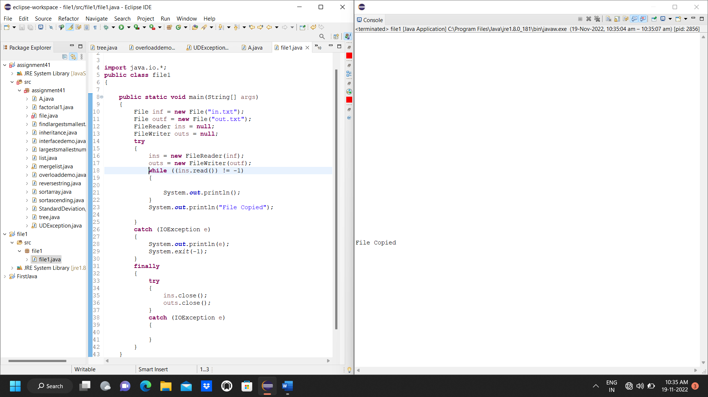

ASSIGNMENT NO 12

**NAME-** Shubham Vijay Borage

**Class-** MCA

**Roll No.-**

**Q**. Write a java program to calculate standard deviation.

**INPUT:**

package assignment41;

import java.lang.Math;

public class StandardDeviation

{

public static void main(String [] args)

{

double[] arr = {2,4,3,5,6,7,8,9,4,3,2};

double StandardDeviation = *SD*(arr);

System.*out*.println("The Standard DEviation : "+StandardDeviation);

}

public static double SD(double arr[])

{

double sum = 0, StandardDeviation = 0;

int length = arr.length;

for(double num : arr)

{

sum += num;

}

double mean = sum/length;

for(double num : arr)

{

StandardDeviation = StandardDeviation + Math.*pow*(num-mean, 2);

}

return Math.*sqrt*((StandardDeviation/length));

}

}

**OUTPUT:**

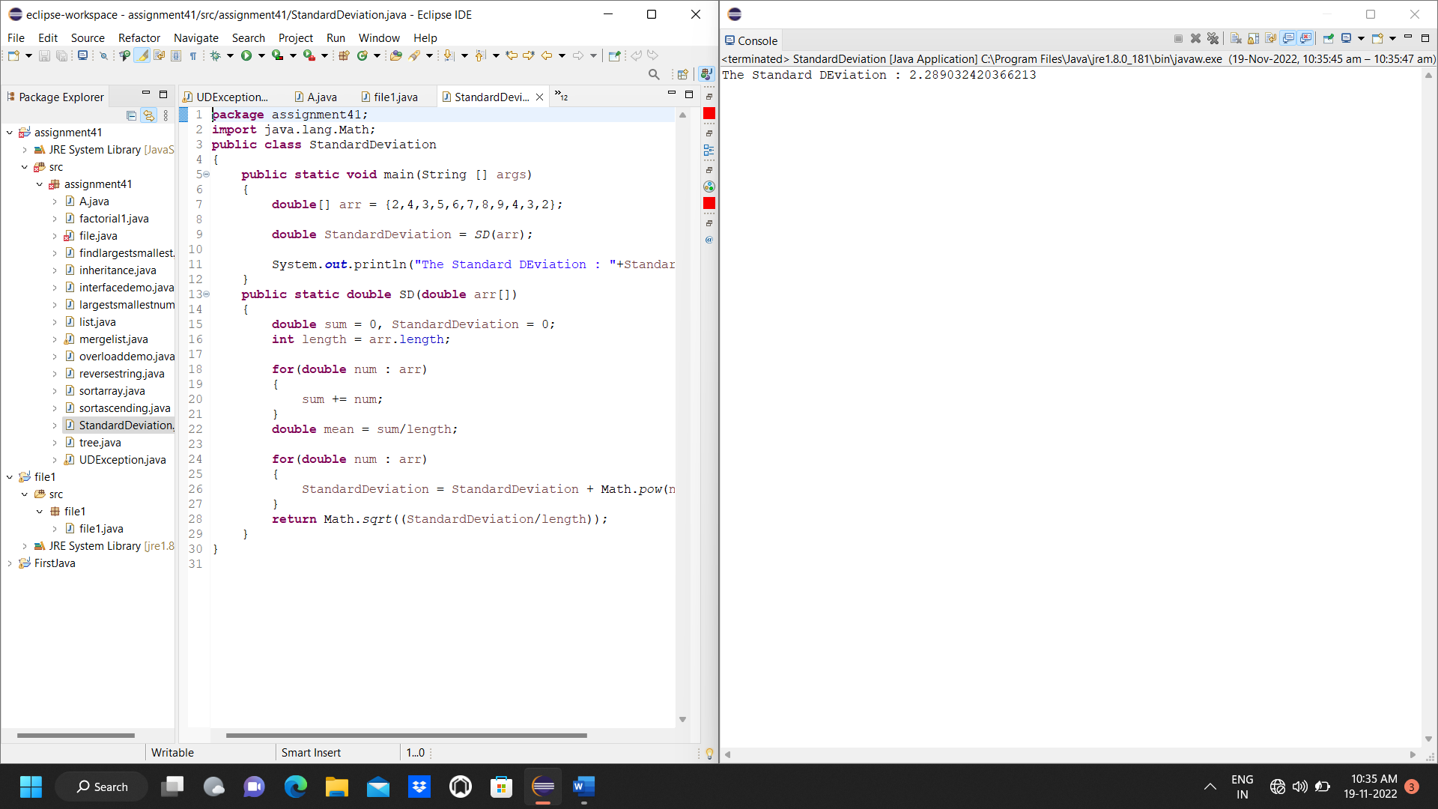

ASSIGNMENT NO 13

**NAME -** Shubham Vijay Borage

**Class -** MCA

**Roll No. -**

**Q**. Write a java program to merge two lists.

**INPUT:**

package assignment41;

import java.util.Scanner;

public class mergelist {

public static void main(String[] args) {

// TODO Auto-generated method stub

Scanner sc = new Scanner(System.*in*);

System.*out*.println("Enter how many values you want in first array?");

int n1=sc.nextInt();

System.*out*.println("Enter how many values you want in second array?");

int n2=sc.nextInt();

int n3=n1+n2;

int[] A=new int[n1];

int[] B=new int[n2];

int[] C=new int[n3];

System.*out*.println("Enter"+n1+"values for array A");

for(int i=0; i<A.length; i++)

A[i]=sc.nextInt();

System.*out*.println("Enter"+n2+"values for array B");

for(int i=0; i<B.length; i++)

B[i]=sc.nextInt();

for(int i=0; i<n1; i++)

C[i]=A[i];

for(int i=0; i<n2; i++)

C[n1+i]=B[i];

System.*out*.println("Merge arrays is:");

for(int i=0; i<C.length; i++)

System.*out*.println(C[i]+" ");

}

}

**OUTPUT:**

